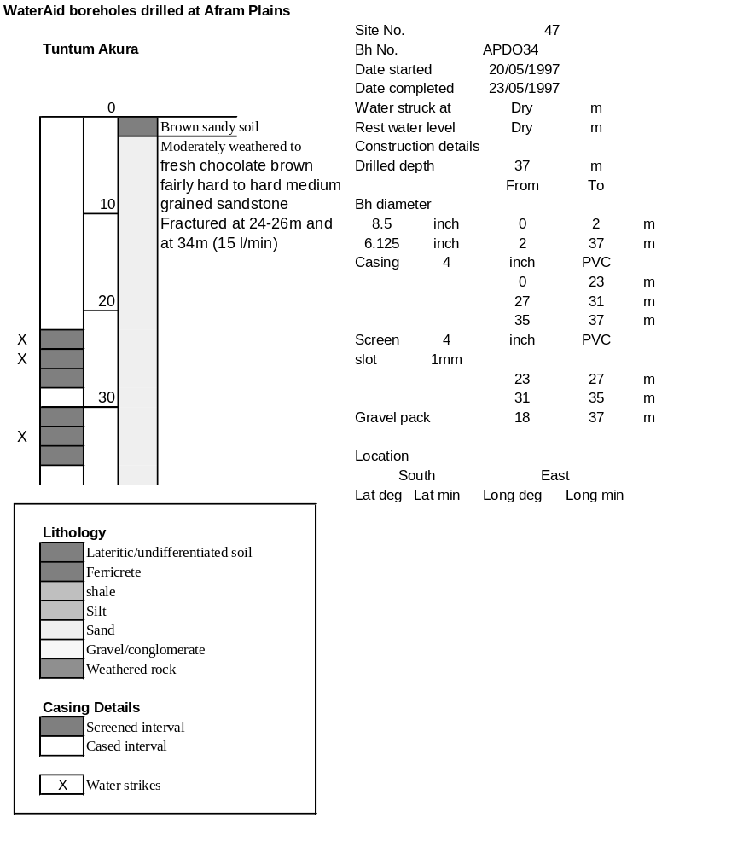

Ghana | Test pumping
Borehole No. |  | APDO 34
Hole No |  | 47
Village |  | Tuntum Akura
Date |  | 11/06/1997
Point below GL |  | 1.06 | m
Pump depth |  | 30 | m
SWL |  | 12.11 | m
Start Time |  | 23:00
Drawdown test |  |  |  |  | Recovery Test
time | pwl (m) | Q l/min | dd | sc(q/s) | Time | wl (m) | t/t' | resdd
0.00 | 12.11 | 9.00 | 0.00 |  | 0.00 | 17.40 |  | 5.29
1.00 | 13.38 | 9.00 | 1.27 | 7.09 | 1.00 | 17.38 | 181.00 | 5.27
2.00 | 13.70 | 9.00 | 1.59 | 5.66 | 2.00 | 17.27 | 91.00 | 5.16
3.00 | 14.05 | 9.00 | 1.94 | 4.64 | 3.00 | 17.15 | 61.00 | 5.04
4.00 | 14.36 | 9.00 | 2.25 | 4.00 | 4.00 | 16.32 | 46.00 | 4.21
5.00 | 14.37 | 9.00 | 2.26 | 3.98 | 5.00 | 16.20 | 37.00 | 4.09
6.00 | 14.83 | 9.00 | 2.72 | 3.31 | 6.00 | 16.09 | 31.00 | 3.98
7.00 | 14.90 | 9.00 | 2.79 | 3.23 | 7.00 | 15.89 | 26.71 | 3.78
8.00 | 14.99 | 9.00 | 2.88 | 3.13 | 8.00 | 15.68 | 23.50 | 3.57
9.00 | 15.31 | 9.00 | 3.20 | 2.81 | 9.00 | 15.54 | 21.00 | 3.43
10.00 | 15.42 | 9.00 | 3.31 | 2.72 | 10.00 | 15.20 | 19.00 | 3.09
12.00 | 15.58 | 9.00 | 3.47 | 2.59 | 12.00 | 14.25 | 16.00 | 2.14
14.00 | 15.83 | 9.00 | 3.72 | 2.42 | 14.00 | 14.68 | 13.86 | 2.57
16.00 | 15.95 | 9.00 | 3.84 | 2.34 | 16.00 | 14.58 | 12.25 | 2.47
18.00 | 16.04 | 9.00 | 3.93 | 2.29 | 18.00 | 14.49 | 11.00 | 2.38
20.00 | 16.13 | 9.00 | 4.02 | 2.24 | 20.00 | 14.44 | 10.00 | 2.33
25.00 | 16.26 | 9.00 | 4.15 | 2.17 | 25.00 | 14.39 | 8.20 | 2.28
30.00 | 16.38 | 9.00 | 4.27 | 2.11 | 30.00 | 14.30 | 7.00 | 2.19
35.00 | 16.50 | 9.00 | 4.39 | 2.05 | 35.00 | 14.26 | 6.14 | 2.15
40.00 | 16.61 | 9.00 | 4.50 | 2.00 | 40.00 | 14.22 | 5.50 | 2.11
45.00 | 16.70 | 9.00 | 4.59 | 1.96 | 45.00 | 14.18 | 5.00 | 2.07
50.00 | 16.79 | 9.00 | 4.68 | 1.92 | 50.00 | 14.14 | 4.60 | 2.03
60.00 | 16.85 | 9.00 | 4.74 | 1.90 | 60.00 | 14.12 | 4.00 | 2.01
70.00 | 16.91 | 9.00 | 4.80 | 1.88 | 70.00 | 14.08 | 3.57 | 1.97
80.00 | 17.01 | 9.00 | 4.90 | 1.84 | 80.00 | 14.03 | 3.25 | 1.92
90.00 | 17.10 | 9.00 | 4.99 | 1.80 | 90.00 | 13.89 | 3.00 | 1.78
100.00 | 17.18 | 9.00 | 5.07 | 1.78 | 100.00 | 13.75 | 2.80 | 1.64
110.00 | 17.21 | 9.00 | 5.10 | 1.76 | 110.00 | 13.64 | 2.64 | 1.53
120.00 | 17.27 | 9.00 | 5.16 | 1.74 | 120.00 | 13.50 | 2.50 | 1.39
140.00 | 17.33 | 9.00 | 5.22 | 1.72
160.00 | 17.36 | 9.00 | 5.25 | 1.71
180.00 | 17.40 | 9.00 | 5.29 | 1.70

